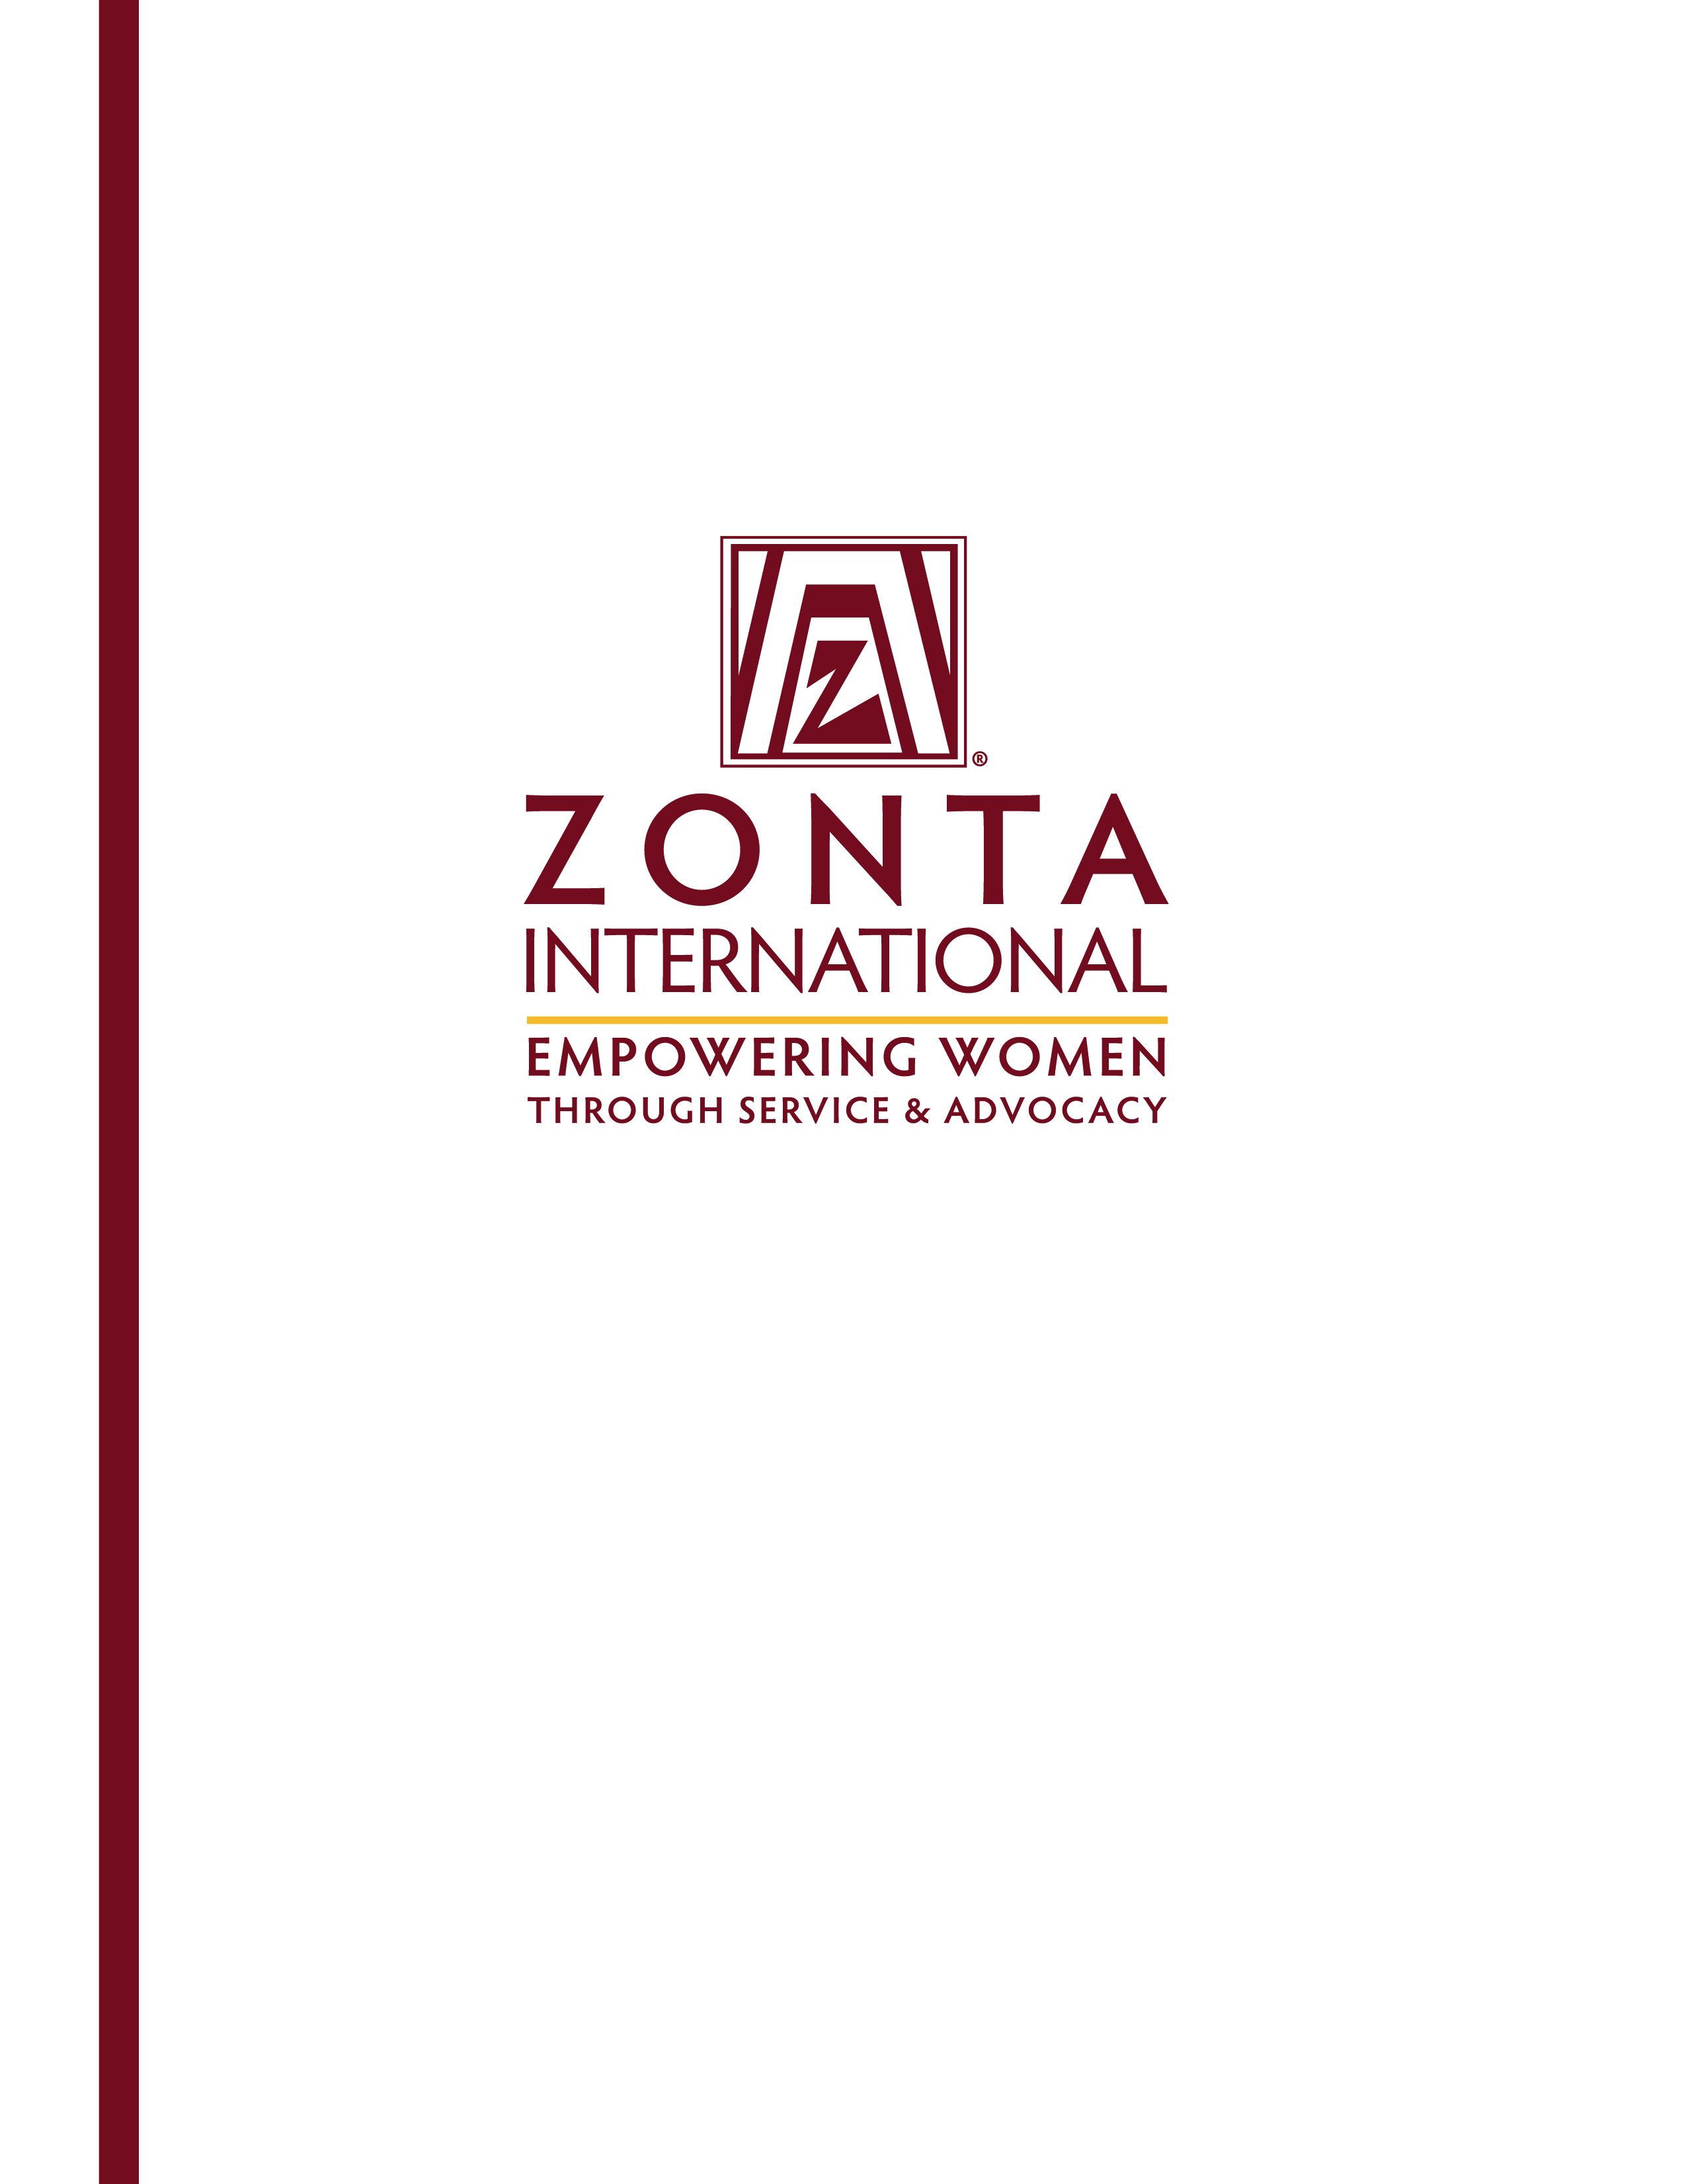
Jane M. Klausman
Women in Business Scholarships
2016 Application
Heading
Subheading

Jane M. Klausman

Women in Business Scholarships
A Zonta International Program, Funded through the Zonta International Foundation

General Information
The Zonta International Foundation awarded the first Jane M. Klausman Women in Business Scholarships in 1998 to women pursuing degrees in business leading to a business management career. This program was established from a bequest by Jane M. Klausman, a member of the Zonta Club of Syracuse, New York, USA, and the 1990-1995 Zonta International Parliamentarian. During her career, Ms. Klausman was a professional secretary, parliamentarian and entrepreneur.

The Scholarship
The Jane M. Klausman Women in Business Scholarships are awarded to women undertaking business studies who have demonstrated outstanding potential in the field. Zonta International offers up to 32 scholarships of US$1,000 each at the district/region level and 12 international scholarships in the amount of US$7,000 each. Any woman undertaking a business and/or business-related program at an accredited university/college/institute, in at least the second year of an undergraduate program through the final year of a Master’s program at the time the application is submitted, is eligible to apply. The Scholarship may be used at any university, college or institute offering accredited courses and degrees. Previous International Jane M. Klausman Women in Business Scholarship recipients may not apply to renew the Scholarship for a second year.

Who is Eligible?
Women of any age, pursuing a business or business-related program who demonstrate outstanding potential in the field and are living or studying in a Zonta district/region, are eligible. Note that applicants from geographic areas where no Zonta clubs are located will be considered and also eligible to apply for the district/region scholarship. Online students are also eligible to apply.

Classified members and employees of Zonta International and Zonta International Foundation, and their family members, are not eligible to apply for the Scholarship.

What are the Requirements?
Applicants must meet the following minimum requirements:
- Be undertaking a business and/or business-related program at an accredited university/college/institute.
- Enrolled in at least the second year of an undergraduate program through the final year of a Master's program at the time the application is submitted (applicants must still be attending school to receive this award).
- Must submit verification of current enrollment (see page 10) with application materials. Acceptance letters are not verification of enrollment and will not be accepted.
- Achieved an outstanding academic record during her academic studies, including business-related subjects.
- Demonstrated initiative, ambition and commitment to pursuing a career in business.

How Do I Apply?
Complete an official application in English. Please note that only typed applications will be accepted and considered. Applications can be downloaded from the Zonta International website, (www.zonta.org) and must include:
- One recommendation from a faculty member in the major field of study.
- One recommendation from an employer, volunteer supervisor, or academic advisor. (Classified members and employees of Zonta International and Zonta International Foundation are not eligible to write recommendation letters for applicants.)
- An essay in 500 words or less that clearly describes your academic and professional goals, the relevance of your program to the business field, and how the Jane M. Klausman Women in Business Scholarship will assist you in reaching your goals.
- Verification of current enrollment form from the university/college/institute registrar (see page 10 of application). Acceptance letters are not verification of enrollment and will not be accepted.
Please note that students from the southern hemisphere may have limited academic records available at the time of application for club and district/region Jane M. Klausman Scholarships. If further records are available at a later date, these records may be included when the district/region forwards their nominee to Zonta International for consideration in the selection of the International Jane M. Klausman Scholarships. Candidates for the International Scholarships may be asked to submit their most recent academic results for consideration.
- Transcripts of grades or equivalent records for all universities, colleges, or institutes, with an explanation of the grading system for each transcript submitted.
- All non-English documents must be translated in English.
- All application materials must be received at the Zonta club by the deadline printed on the application. If the Zonta club contact information is not printed on the application, please locate a Zonta club nearest you by using the Club Locator at http://www.zonta.org, or email your name and contact information to Zonta International Headquarters at programs@zonta.org. Please note that applicants may not apply to more than one Zonta district.
- Articles, pamphlets, books, curriculum vitae or other publications are not requested and will not be considered.
- Applications that are incomplete or late due to postal delays, transmittal by third parties, or other circumstances will not be considered. Applications are accepted by email or regular mail; however, email submissions are preferred. Applications submitted by email must be signed and sent as a PDF.

What is the Application Process?
The club evaluation committee will consider applications and select the club awardee. Applications selected by Zonta clubs are sent to their respective Zonta governors/regional representative. A district/region evaluation committee selects one applicant per district/region to submit to Zonta International Headquarters. The Zonta International Jane M. Klausman Women in Business Scholarship Committee selects 12 international recipients from the district/region applicants.

How May I Use the Scholarship Funds?
- The scholarship may be used for any expenses that support the achievement of a degree in a business-related field.
- For domestic and foreign recipients studying in the United States, scholarship funds used for tuition, books, fees, supplies or required equipment for the program of study are not considered taxable income. Withholding taxes may be required on funds used for living expenses or other non-qualified expenses.
- Recipients are not permitted to defer the Scholarship. Zonta International will consider a new application the following year, but no preferential consideration will be given to the second application.
- Recipients may accept additional grants and scholarships from other sources.

Timetable
Applications received by Zonta clubs (contact local club for deadline-generally in April/May)
Club recipient is selected and application is received by governor/regional representative........................................1 July
(This date might vary in the northern and southern hemispheres. Please contact your governor/regional representative for deadline.)
District/region recipient selected and application received by Zonta International Headquarters.….…….…..1 September
Official announcement of district/region and international recipients….……………….……….……………mid-October

Application for Jane M. Klausman

Women in Business Scholarship
SEND APPLICATION AND DIRECT ANY QUESTIONS TO:

Application Deadline: | 15th of May, 2016
Zonta club of: | Warszawa
District/Area: | 27/04
To find a club click: | Club Locator

Attention:
Address: | Platowcowa 19/2
City/State: | 02-635 Warszawa
Province/Country: | Poland
Telephone: | +48602576644
Email address: | zontawa@poczta.onet.pl

Name:
 |  | Last (Family) | First | Middle

Present mailing address:

City: |  | State: |  | Postal Code: |  | Country:

Email address: |  | Telephone:

Permanent Mailing Address:

City: |  | State: |  | Postal Code: |  | Country:

Home email address: |  | Telephone:

Birth date: |  | Birthplace: |  | Country of citizenship:
(date/month/year)
University/college/institute currently attending: |  |  | Current year of study:

Department: |  | Major/field of study:

Plans for study under the Jane M. Klausman Women in Business Scholarship:

Degree sought: |  | Expected graduation date (month/year):

Academic Background
Applicants are required to send transcripts of grades or equivalent records from all universities, colleges or institutes attended. An explanation of the grading system must be included for each transcript.

University/college/institute | (Year) to (Year) | Major field | Date of degree/anticipated
Scholarships, Fellowships, Honors Received During the Studies Listed Above
(Attach an additional sheet if necessary)

Date:
Date:
Date:
Date:
Date:
Date:
Date:
Volunteer and Other Activities
(Please describe your volunteer, non-scholastic activities, memberships and cultural interests):

Employment

From (month/year) | To (month/year) | Employer | Address | Type of work or position held

Recommendations
Please give one of the attached recommendation forms to a faculty member in the major field of study and the other to an employer, volunteer supervisor, or academic advisor.

Please list below those who will submit recommendations:

Name | Position | College/university/institute
1.
2.

Declaration by Applicant

I will take responsibility for school expenses (such as living, traveling, clothing) which are in excess of the US$7,000 grant should I be the recipient of an International Jane M. Klausman Women in Business Scholarship. I grant permission to Zonta International and Zonta International Foundation to use my name and photograph in the literature designed to promote the Zonta International Jane M. Klausman Women in Business Scholarships.

I certify that all of the information contained in my application form is accurate to the best of my knowledge. I understand that, at the option of the Zonta club sponsoring my application or the Zonta district/region, or Zonta International, I may be interviewed as a candidate for the Jane M. Klausman Women in Business Scholarship. I consent to the electronic or hard copy publication by Zonta International of material in my application.

I confirm that I have not applied to more than one Zonta district.

Signature |  | Date

How did you learn of the Jane M. Klausman Women in Business Scholarship?

Please check the appropriate items:
Social media
Department/teacher
Directory of grants at university of financial aid office
Directory of grants not at university (e.g. public libraries)
Website (name):
Zonta club member:
Zonta club of:
Other:

Applicant checklist

Please check all items included with the application:
Completed application in English
Official transcripts
Recommendations (2)
Essay
Verification of current enrollment form with official stamp of the college/university/institute
Signature

PROFESSIONAL INFORMATION AND GOALS

(Please type in English.)
In 500 words or less, please describe your academic and professional goals, the relevance of your program to the business field, and how the Zonta International Jane M. Klausman Women in Business Scholarship will assist you in reaching your goals.

Recommendation for
Jane M. Klausman Women in Business Scholarship

Please return this form by: | zontawa@poczta.onet.pl

Applicant’s Signature

Applicant:
 |  | Last (Family) Name |  | First |  |  | Middle
Recommendation from:
 |  |  | Name |  |  | Position/Title

College/university/institute/business/organization

The applicant above has applied for a Jane M. Klausman Women in Business Scholarship. The Jane M. Klausman Women in Business Scholarship Evaluation Committee greatly values and appreciates your opinion. Please discuss the applicant’s accomplishments; current academic program or work experience; intellectual independence; capacity for analytical thinking; ability to organize and express ideas clearly; creativity; motivation; and potential for learning and succeeding in a business-related field. You may use an additional piece of paper.

How long have you known the applicant?
Please rate the applicant with respect to your experience with other students/employees in this field/position:
Exceptional  Top 5% | Very Good  Next 10% | Good  Next 15% |  | Average  Next 30% | Below Average  Last 40% |  | Insufficient opportunity to observe

Signature |  | Date

Return form to Zonta club of: |  | Address: |  | City:
State/Province: |  | Country: |  | Postal Code:
Fax: |  |  | Email address:

Recommendation for
Jane M. Klausman Women in Business Scholarship

Please return this form by: | zontawa@poczta.onet.pl

Applicant’s Signature

Applicant:
 |  | Last (Family) Name |  | First |  |  | Middle
Recommendation from:
 |  |  | Name |  |  | Position/Title

College/university/institute/business/organization

The applicant above has applied for a Jane M. Klausman Women in Business Scholarship. The Jane M. Klausman Women in Business Scholarship Evaluation Committee greatly values and appreciates your opinion. Please discuss the applicant’s accomplishments; current academic program or work experience; intellectual independence; capacity for analytical thinking; ability to organize and express ideas clearly; creativity; motivation; and potential for learning and succeeding in a business-related field. You may use an additional piece of paper.

How long have you known the applicant?
Please rate the applicant with respect to your experience with other students/employees in this field/position:
Exceptional  Top 5% | Very Good  Next 10% | Good  Next 15% |  | Average  Next 30% | Below Average  Last 40% |  | Insufficient opportunity to observe

Signature |  | Date

Return form to Zonta club of: |  | Address: |  | City:
State/Province: |  | Country: |  | Postal Code:
Fax: |  |  | Email address:

Verification of Current Enrollment
Jane M. Klausman Women in Business Scholarship

I certify that |  | is currently enrolled in
 | (name of student)

 | in
(year of degree program ) |  | (name of course/degree being studied)

at
(name of college/university/institute)

(address college/university/institute)

(signature of college/university/institute official) |  | (date)

(official stamp of the college/university/institute )

This requirement may be deferred if the application deadline precedes the university/college/institute enrollment period. The applicant must provide written confirmation of the enrollment period with the application. Acceptance letters are not verification of enrollment and will not be accepted. Scholarship recipients must provide verification of enrollment before scholarship funds will be released in November.

Students from the Southern Hemisphere may only have limited academic records available at the time of application for club and district Jane M. Klausman Scholarships. If further records are available at the later date, these records may be included when the district forwards their nominee to Zonta International for consideration in the selection of the International Jane M. Klausman Scholarship.

